**INTRODUCTION**

* 1. **OVERVIEW**

**Retail management refers to the process of helping customers find products in your store. It includes everything from increasing your customer pool to how products are presented , and how you fulfill a customer’s needs .**

**SALESFORCE**

**Sales force is your customer success platform, designed to help you sell, service, marketing, analyze and connect with your customer.**

**OBJECTS:**

**Objects are database tables that permit you to store data that is specific to an organization . Sales force objects are two types**

**1 .Standard objects 2 .Custom objects**

**RELATION BETWEEN THE OBJECTS:**

**Object relationship are special field types that connect two objects .As CRM product owner create relationship to link objects with each other , so that when uses view records , they can also see related data.**

**APPLICATION:**

**Apps in sales force are a group of tabs that help the application function by working together as a unit . It has a name ,a logo and a particular an app is a collection of items that work together to serve a particular function . Sales force apps come in two flavors : classic and lighting.**

**LAYOUTS:**

**Page layouts control the layout of an object.**

**USERS:**

**A user is anyone who logs in sales force . Users are employees at your company.**

**VALIDATION RULE:**

**Validation rule is verify the data users.**

**ROPORTS:**

**A report is a list of records that meet the criteria your define . It’s displayed in salesforce in rows and columns and can filtered , grouped or displayed in a graphical chart . Every report is stored in a folder .**

**DASHBOARD:**

**Dashboard is sales force are a graphical representation of report .**

* 1. **PURPOSE**
* **Retail management improves overall company cohesion .**
* **Retail store management improves customer experience and boosts customer satisfaction .**
* **Retail operation management contributes to business growth.**

**PROBLEM DEFINITION & DESIGN THINKINK**

**2.1 EMPATHY MAP**

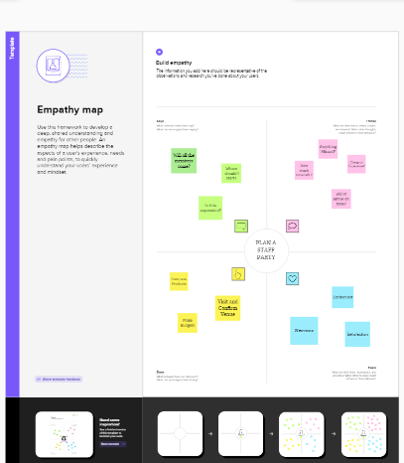

**2.2 IDEATION & BRAINSTORMING MAP**

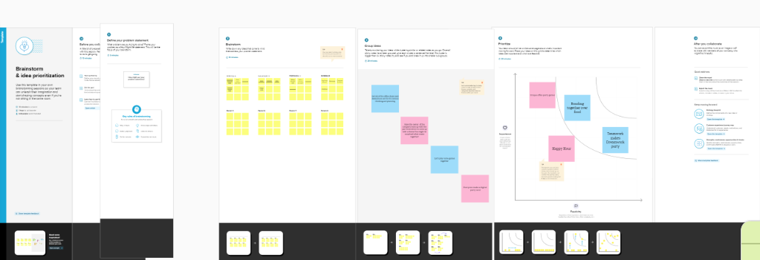

**RESULT**

**3.1 DATA MODEL**

|  |  |
| --- | --- |
| **Object**  **name** | **Fields in the object** |
| **Obj 1** | |  |  | | --- | --- | | **Field Label** | **Data Type** | | **Warehouse** | **Master detail(warehouse)** | |
| **Obj 2** | |  |  | | --- | --- | | **Product** | **Master detail(product)** | | **Stock** | **Checkbox** | |
| **Obj 3** | |  |  | | --- | --- | | **Sales order** | **Master detail(sales order)** | | **Dispatch**  **tracking** | **Master datail** | |
| **Obj 4** | |  |  | | --- | --- | | **Field Label** | **Data Type** | | **Accounts** | **Text** | |

**3.2 ACTIVITY &SCREENSHOT**

**Custom object:**

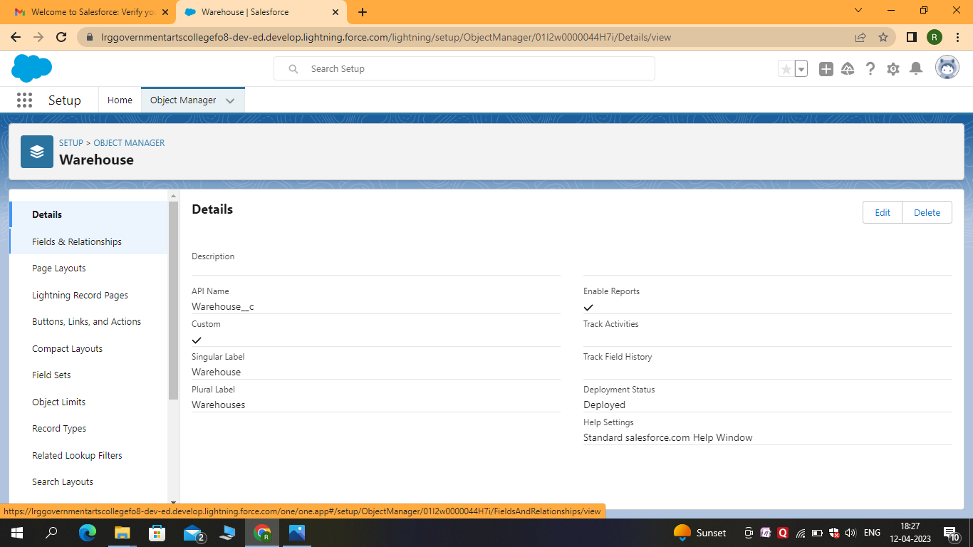

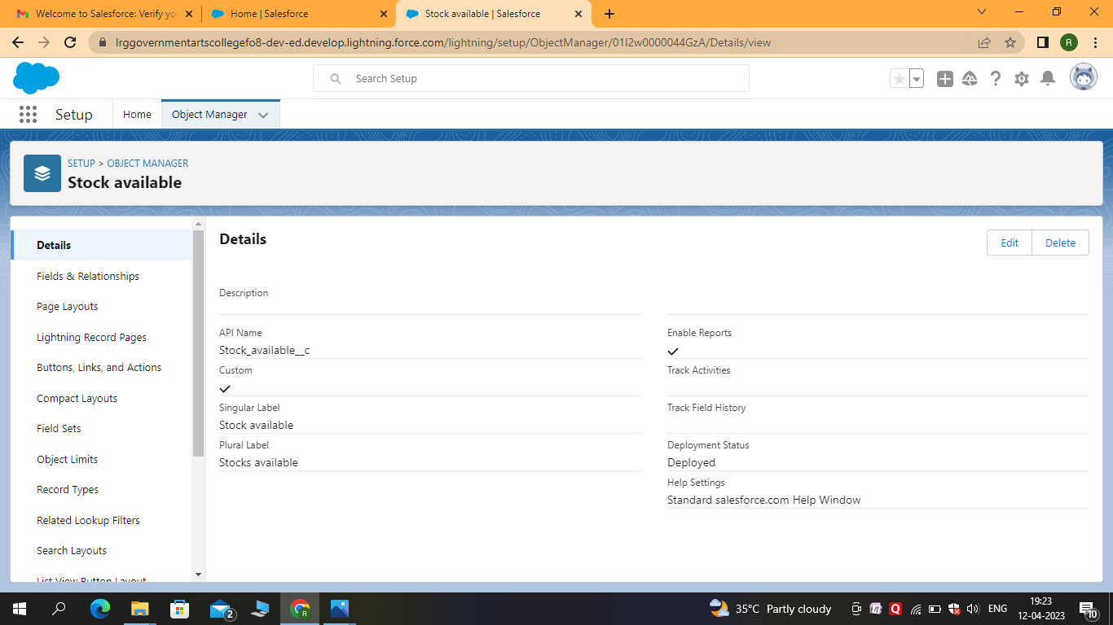

**TABS:**

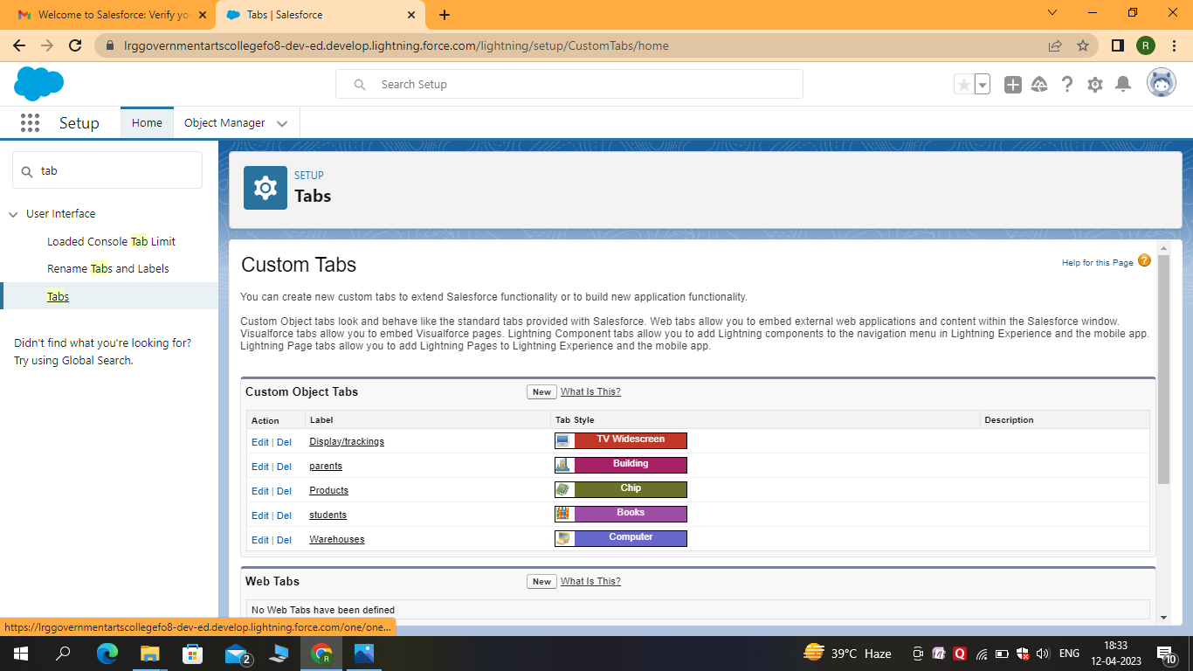

**RELATION BETWEEN OBJECTS:**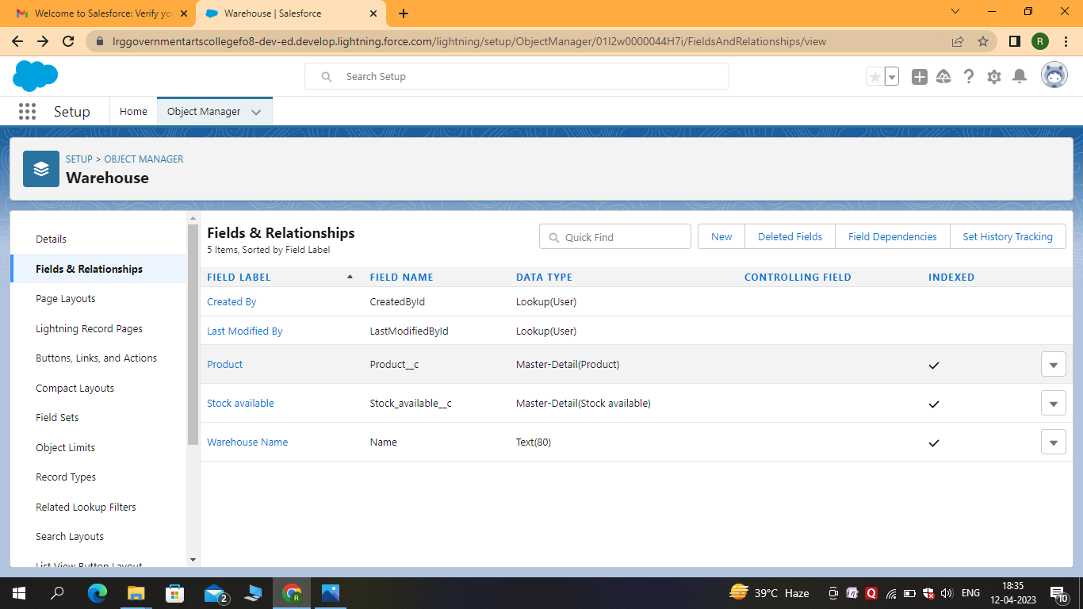

**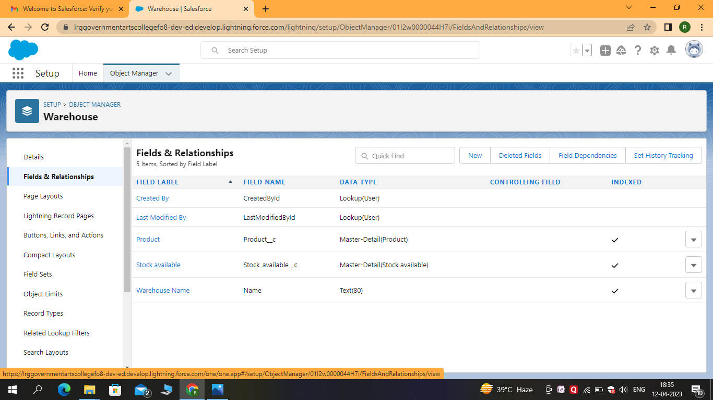  
APPLICATION:**

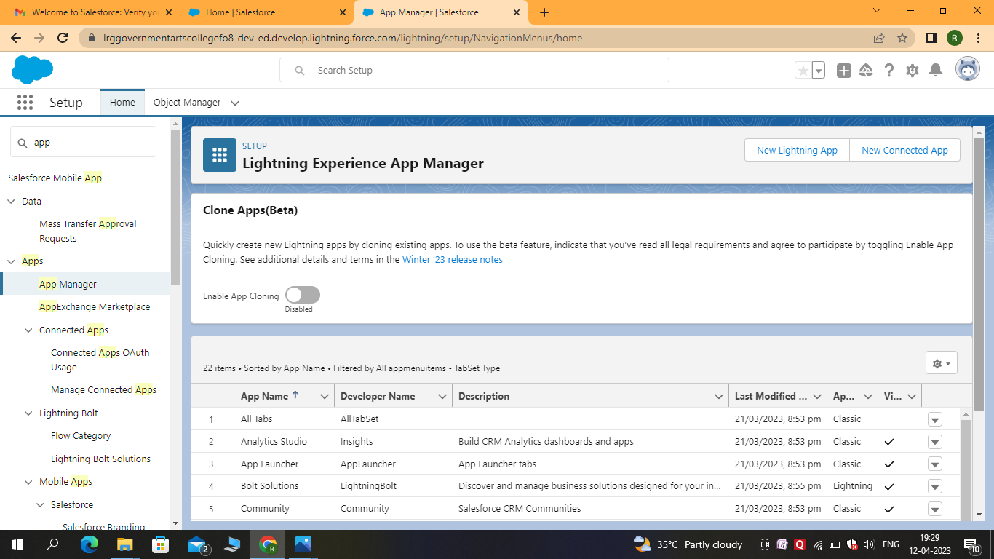

**LAYOUTS:**

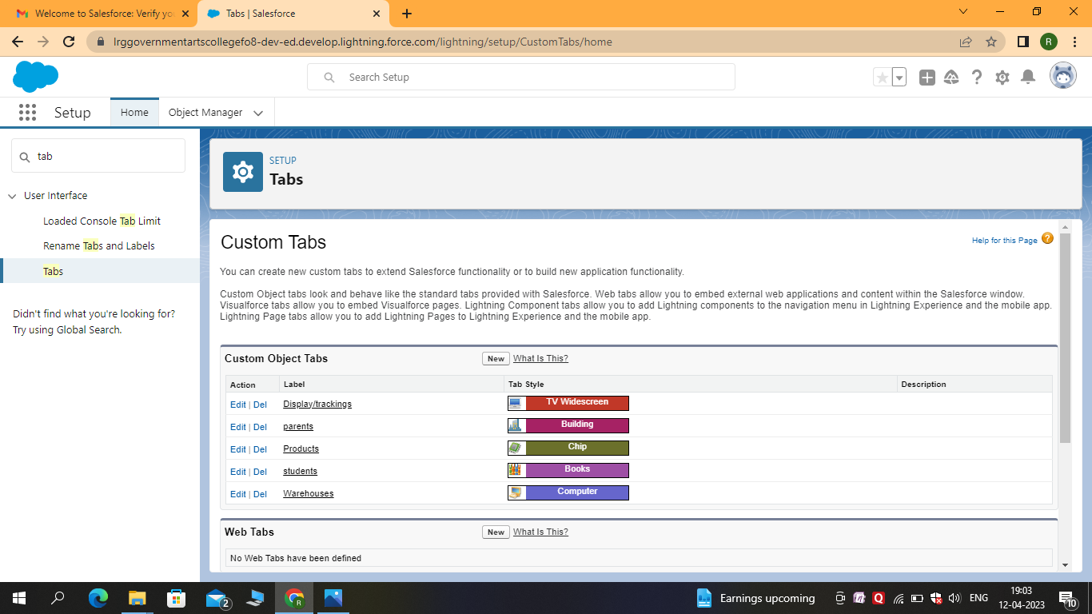

**USERS:**

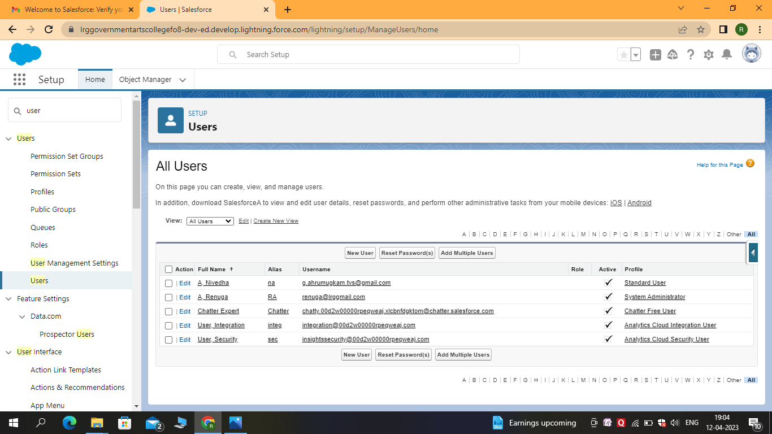

**VALIDATION RULE:**

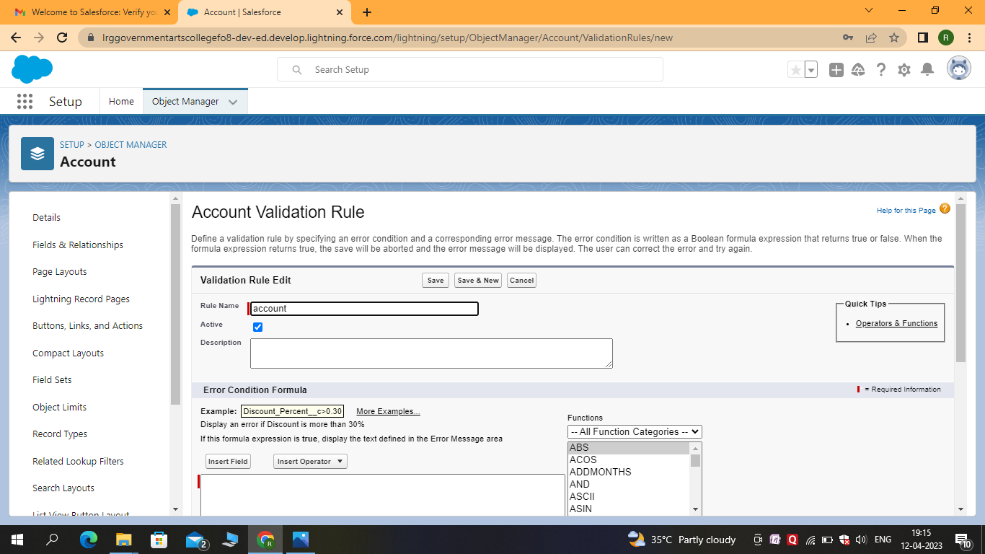

**FORMULA:**

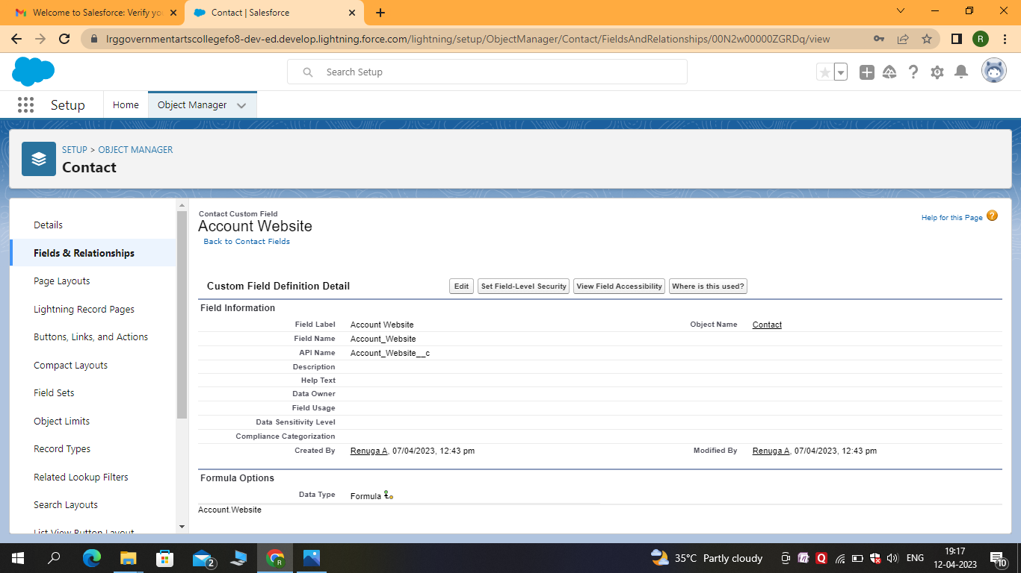

**REPORTS:**

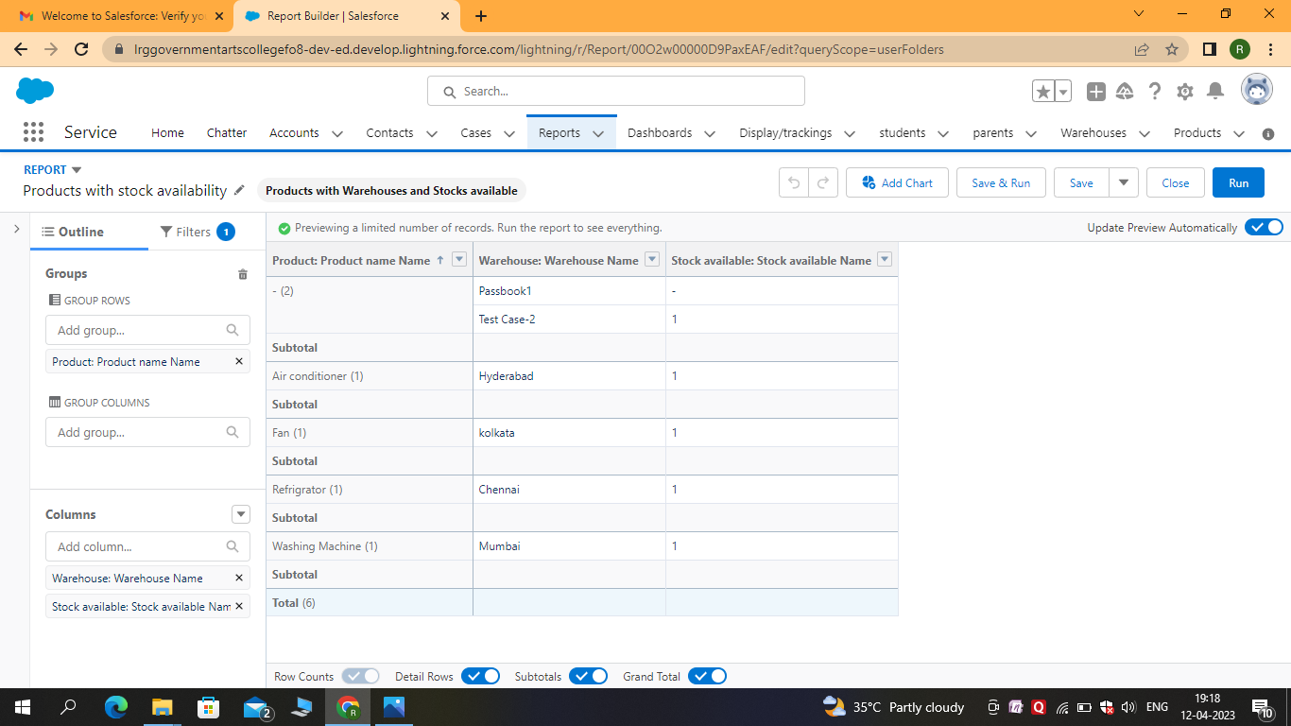

**DASHBOARDS:**

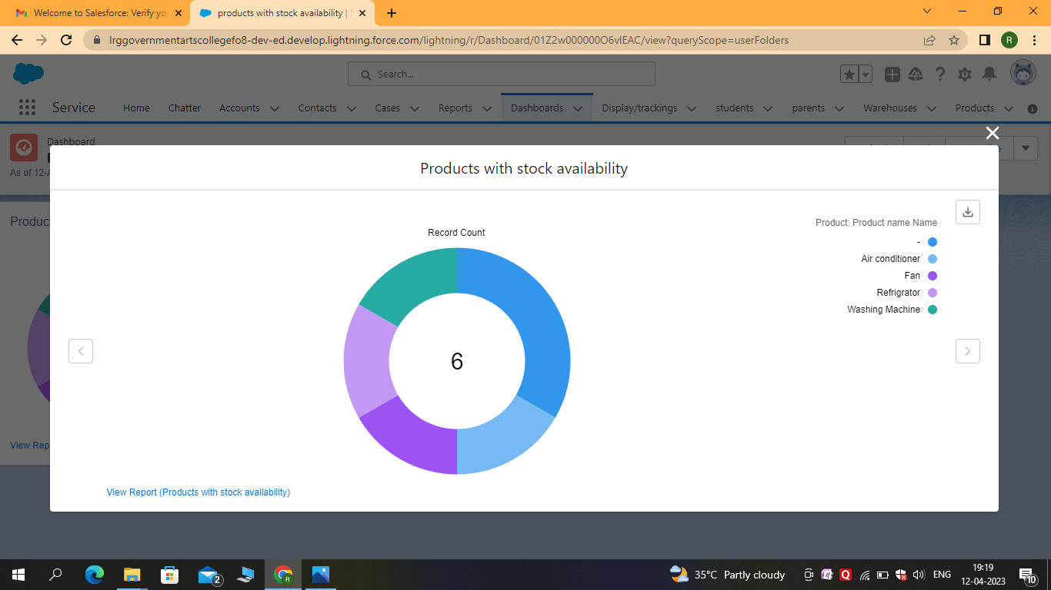

**TRAILHEAD PROFILE PUBLIC URL**

**Team Lead –** <https://tailblazer.me/id/renua10>

**Team Member 1 –**<https://trailblazer.me/id/kalar24>

**Team Member 2 –**<https://trailblazer.me/id/peerj>

**Team Member 3 –**<https://trailblazer.me/id/rrubikar>

**ADVANTAGES & DISADVANTAGES**

**ADVANTAGES:**

* **Sales processes and make them more efficient .**
* **With sales force , you can keep track of your customer’s movements and interactions in a centralized location .**
* **Sales force allows you to customize the platform to suit your specific needs .**
* **Creating a sustainable competitive advantage .**

**DISADVANTAGE:**

* **You have to pay for add-ons to get the most out of the software .**
* **Configuration and setup is complex and time - consuming .**
* **Cluttered interface makes navigation and simple tasks unnecessarily complex .**
* **The learning curve never seems to end .**
* **Customer support has a poor reputation .**
* **Expensive**

**APPLICATIONS**

* **Buying**
* **Pricing**
* **Merchandising**
* **Marketing**
* **Personnel**
* **Customer service**
* **Training**
* **Operations**

**CONCLUSION**

**Customer Relationship Management enables a company to align its strategy with the needs of the customer in order to best meet** **those needs and thus** ensure long-term customer loyalty.

**FUTURE SCOPE**

* **Retail Manager**
* **Store Manager**
* **Retail Buyer**
* **Warehouse Manager**
* **Brand Manager**
* **Customer Care Executive**
* **Image Promoter**
* **Merchandise Manager**
* **Merchandiser Analys**